PHASE 5
BACKEND DEVELOPMENT

Objective:
To develop the backend server, REST APIs, authentication, validation and blog management functionalities of the AI BlogNest system.

Backend Technologies:
- Node.js
- Express.js
- Mongoose
- MongoDB
- JWT
- bcrypt.js
- express-validator

Backend Development Activities:
- Created the Express.js server.
- Connected the application with MongoDB.
- Created User and Blog models using Mongoose.
- Implemented user registration and login.
- Implemented JWT-based authentication.
- Added password hashing using bcrypt.js.
- Implemented blog creation, viewing, updating and deletion.
- Added input validation and error handling.
- Created separate routes, controllers and middleware for better project organization.

Main API Endpoints:
- POST /api/auth/register – User registration
- POST /api/auth/login – User login
- GET /api/auth/profile – Get user profile
- POST /api/blogs – Create a blog
- GET /api/blogs – Get all blogs
- GET /api/blogs/:id – Get a specific blog
- PUT /api/blogs/:id – Update a blog
- DELETE /api/blogs/:id – Delete a blog

Expected Output:
A functional backend server with secure authentication, database connectivity and complete blog CRUD operations.

Testing:
The backend APIs were tested using Postman / Thunder Client.

Phase Status:
Completed.

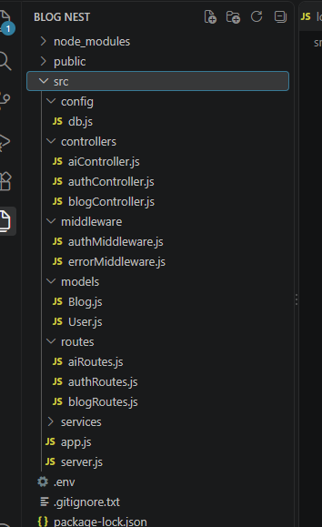
Figure 5.1: AI BlogNest Backend Project Structure

